# VELAGAPUDI RAMAKRISHNA SIDDHARTHA ENGINEERING COLLEGE



# MOBILE APPLICATION DEVELOPMENT HOME ASSIGNMENT

**17CS3652B**

**Submitted By:** **Submitted To:**

Tellakula Avinash

A .Raghuvira Pratap

198W1A05C0

Assistant Professor

CSE-2

**Aim:**

Develop an android application to implement push notifications app

**Software’s /IDE Tools:**

Android Development Kit / Android Studio

**Application User interface design:**

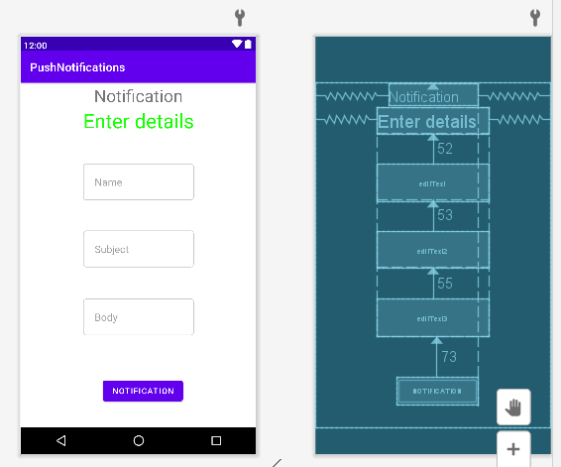

**Application Programming Interface:**

|  |  |  |  |
| --- | --- | --- | --- |
| **API / PACKAGES** | **CLASSES / INTERFACES** | **METHODS** | **DESCRIPTION** |
| import androidx.appcompat.app.AppCompatActivity; | AppCompatActivity | protected void onCreate(Bundle savedInstanceState) | onCreate(Bundle) is where you initialize your activity. When Activity is started and application is not loaded, then both onCreate() methods will be called. |
|  |  |
| import android.widget.EditText; | EditText | getText() | Determines the minimum type that getText() will return. If set, specifies that this TextView has a textual input method and should automatically capitalize what the user types. |

**Code/Implementation:**

// Develop an android application to implement push notifications

**MainActivity.java**

package com.eswar.pushnotifications;  
  
import android.app.Notification;  
import android.app.NotificationManager;  
  
import android.content.Context;  
*//import android.support.v7.app.ActionBarActivity;*import android.os.Bundle;  
import android.view.View;  
  
import android.widget.Button;  
import android.widget.EditText;  
  
import androidx.appcompat.app.AppCompatActivity;  
  
public class MainActivity extends AppCompatActivity {  
 EditText ed1,ed2,ed3;  
 protected void onCreate(Bundle savedInstanceState) {  
 super.onCreate(savedInstanceState);  
 setContentView(R.layout.*activity_main*);  
  
 ed1=(EditText)findViewById(R.id.*editText*);  
 ed2=(EditText)findViewById(R.id.*editText2*);  
 ed3=(EditText)findViewById(R.id.*editText3*);  
 Button b1=(Button)findViewById(R.id.*button*);  
  
 b1.setOnClickListener(new View.OnClickListener() {  
 @Override  
 public void onClick(View v) {  
 String tittle=ed1.getText().toString().trim();  
 String subject=ed2.getText().toString().trim();  
 String body=ed3.getText().toString().trim();  
  
 NotificationManager notif=(NotificationManager)getSystemService(Context.*NOTIFICATION_SERVICE*);  
 Notification notify=new Notification.Builder  
 (getApplicationContext()).setContentTitle(tittle).setContentText(body).  
 setContentTitle(subject).setSmallIcon(R.drawable.*download*).build();  
  
 notify.flags |= Notification.*FLAG_AUTO_CANCEL*;  
 notif.notify(0, notify);  
 }  
 });  
 }  
}

**activity_main.xml:**

*<?*xml version="1.0" encoding="utf-8"*?>*<RelativeLayout xmlns:android="http://schemas.android.com/apk/res/android"  
 xmlns:tools="http://schemas.android.com/tools" android:layout_width="match_parent"  
 android:layout_height="match_parent"  
 android:padding="@dimen/cardview_default_elevation"  
 tools:context=".MainActivity"><TextView  
 android:layout_width="wrap_content"  
 android:layout_height="wrap_content"  
 android:text="Notification"  
 android:id="@+id/textView"  
 android:layout_alignParentTop="true"  
 android:layout_centerHorizontal="true"  
 android:textSize="30dp" />  
 .  
 <TextView  
 android:layout_width="wrap_content"  
 android:layout_height="wrap_content"  
 android:text="Enter details"  
 android:id="@+id/textView2"  
 android:layout_below="@+id/textView"  
 android:layout_centerHorizontal="true"  
 android:textSize="35dp"  
 android:textColor="#ff16ff01" />  
  
 <EditText  
 android:layout_width="wrap_content"  
 android:layout_height="wrap_content"  
 android:id="@+id/editText"  
 android:layout_below="@+id/textView2"  
 android:padding="20dp"  
 android:layout_alignLeft="@+id/textView2"  
 android:layout_alignStart="@+id/textView2"  
 android:layout_marginTop="52dp"  
 android:background="@drawable/edit_background"  
 android:layout_alignRight="@+id/textView2"  
 android:layout_alignEnd="@+id/textView2"  
 android:hint="Name" />  
  
 <EditText  
 android:layout_width="wrap_content"  
 android:layout_height="wrap_content"  
 android:id="@+id/editText2"  
 android:hint="Subject"  
 android:padding="20dp"  
 android:layout_marginTop="53dp"  
 android:layout_below="@+id/editText"  
 android:layout_alignLeft="@+id/editText"  
 android:background="@drawable/edit_background"  
 android:layout_alignStart="@+id/editText"  
 android:layout_alignRight="@+id/editText"  
 android:layout_alignEnd="@+id/editText" />  
  
 <EditText  
 android:layout_width="wrap_content"  
 android:layout_height="wrap_content"  
 android:inputType="textPersonName"  
 android:ems="10"  
 android:id="@+id/editText3"  
 android:layout_marginTop="55dp"  
 android:padding="20dp"  
 android:hint="Body"  
 android:layout_below="@+id/editText2"  
 android:background="@drawable/edit_background"  
 android:layout_alignLeft="@+id/editText2"  
 android:layout_alignStart="@+id/editText2"  
 android:layout_alignRight="@+id/editText2"  
 android:layout_alignEnd="@+id/editText2" />  
  
 <Button  
 android:layout_width="wrap_content"  
 android:layout_height="wrap_content"  
 android:text="Notification"  
 android:id="@+id/button"  
 android:layout_marginTop="73dp"  
 android:layout_below="@+id/editText3"  
 android:layout_alignRight="@+id/textView"  
 android:layout_alignEnd="@+id/textView" />  
  
</RelativeLayout>

**Edit_background.xml:**

*<?*xml version="1.0" encoding="utf-8"*?>*<shape xmlns:android="http://schemas.android.com/apk/res/android" android:shape="rectangle">  
 <stroke android:width="1dp" android:color="@color/cardview_shadow_start_color" />  
 <corners android:radius="5dp"/>  
 <solid android:color="@color/white"/>  
</shape>

**OUTPUT:**

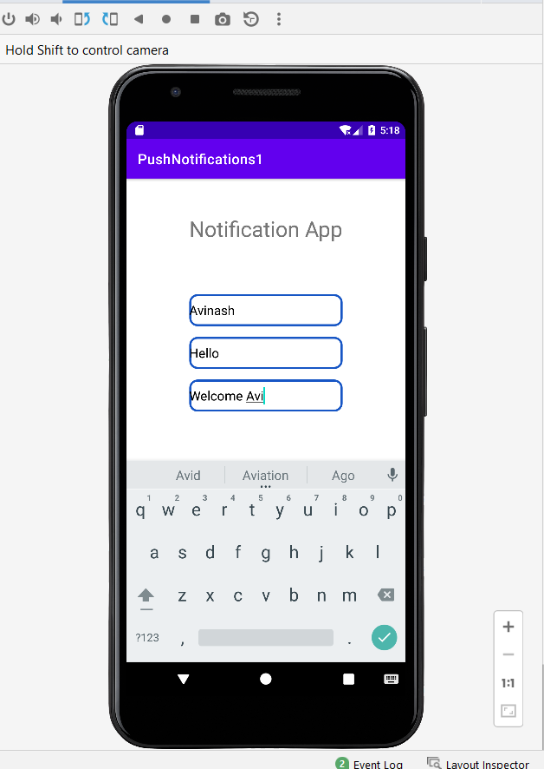

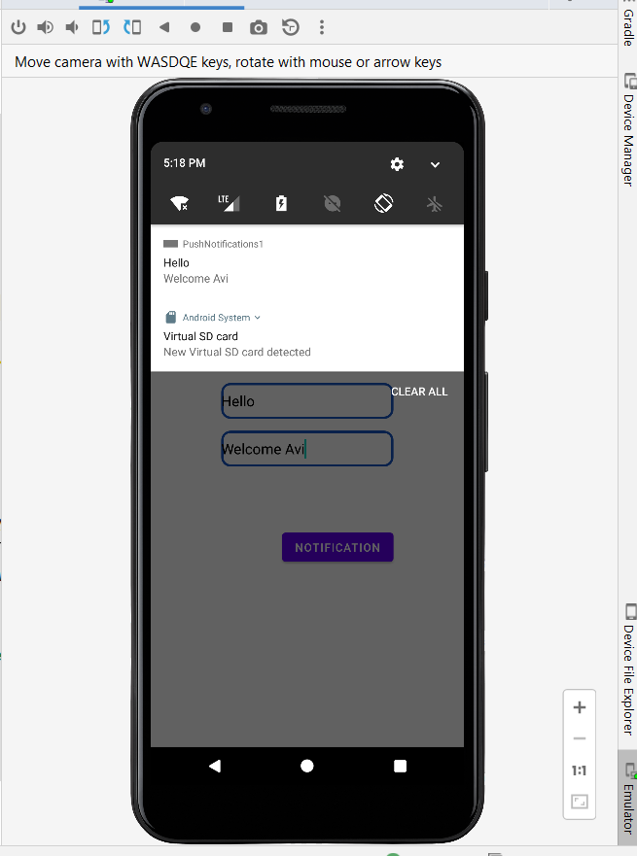

**Result:**

Demonstration of the DatePicker Application were done successfully